**MODULE 6**

1.What are events in Google analytics?

In Google Analytics, "Events" are user interactions with your website or app that can be tracked independently of a web page or screen load. They provide insights into how users are engaging with your content and help you measure specific actions that standard metrics like pageviews or session duration might not capture.

2.Connect your created website and blog to search console, analytics, and google tag manager and add your faculty as a user with required permission in it.

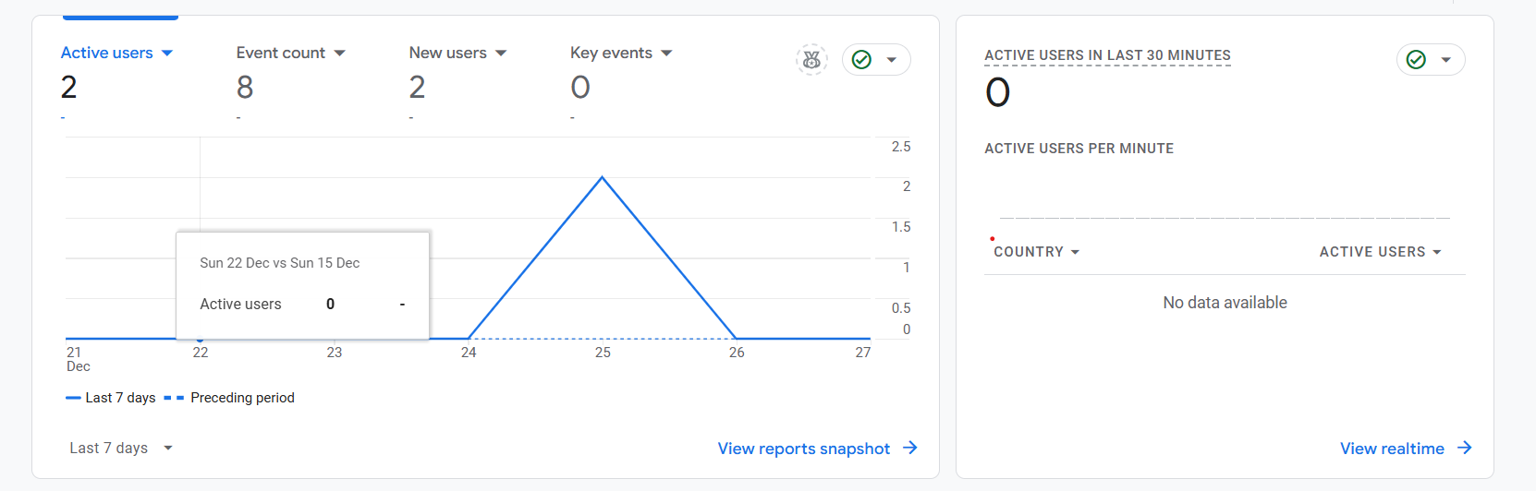

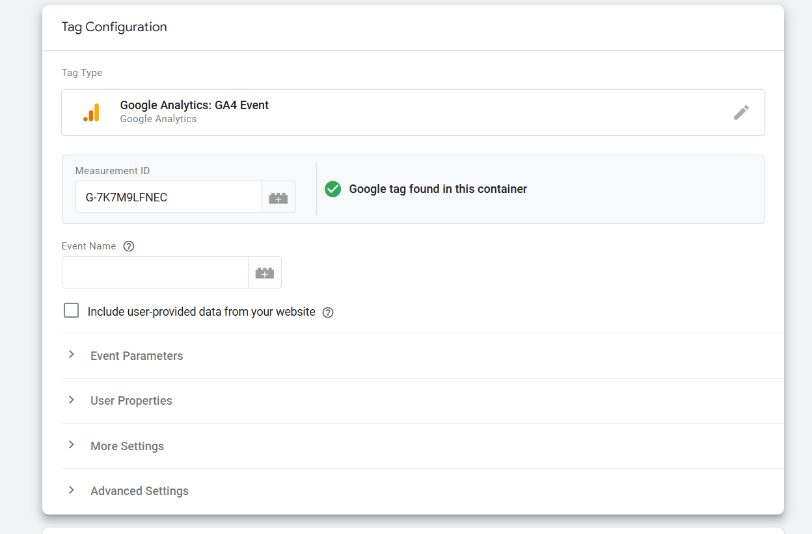

3.Submit the sitemap and robot.txt file in the search console for your website.

Robot.txt file :

A robot.txt file is used to instruct web crawlers (such as Googlebot) on how to interact with a website.

User-agent:*

Disallow : /admin/

We have to add this file in the root directory of our website

Eg : www.finnkit.com/robots.txt

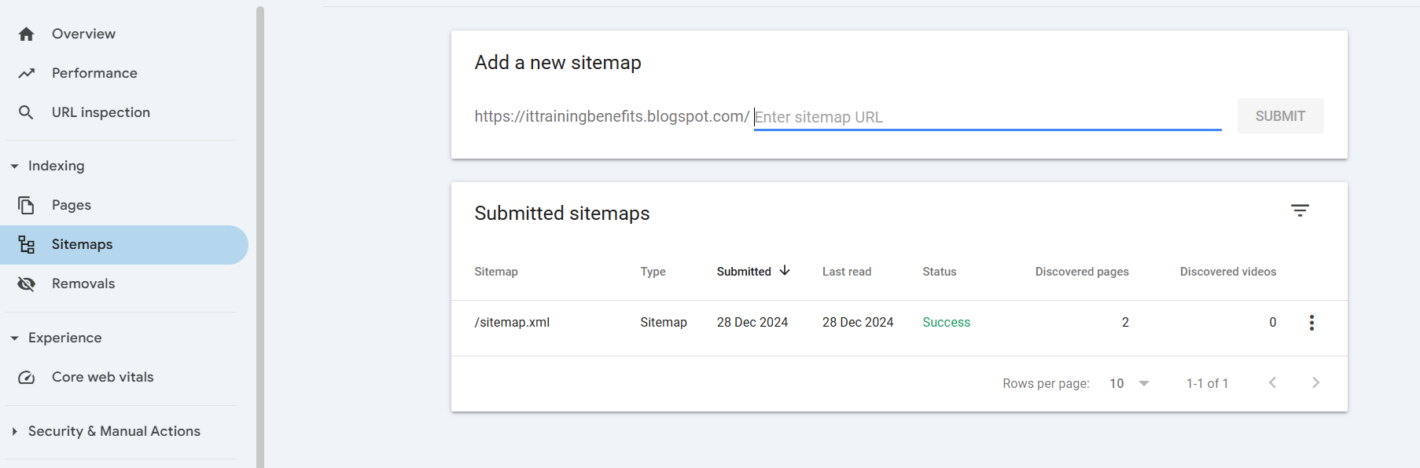

4.Submit the user flow and traffic source reports for your website.

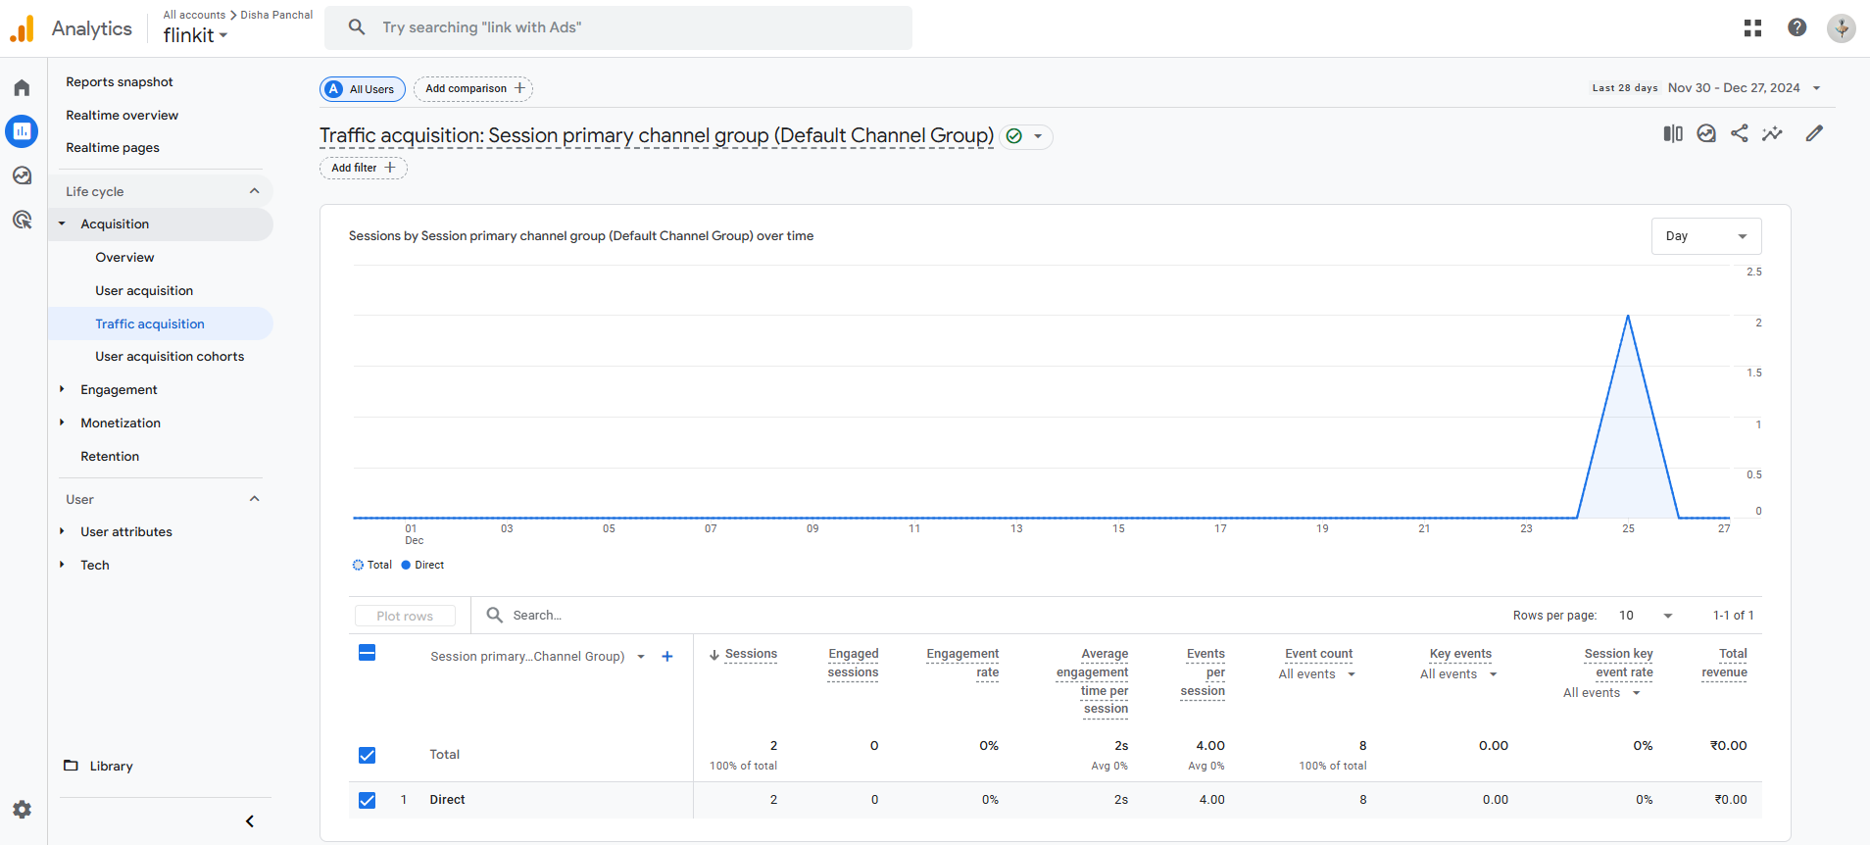

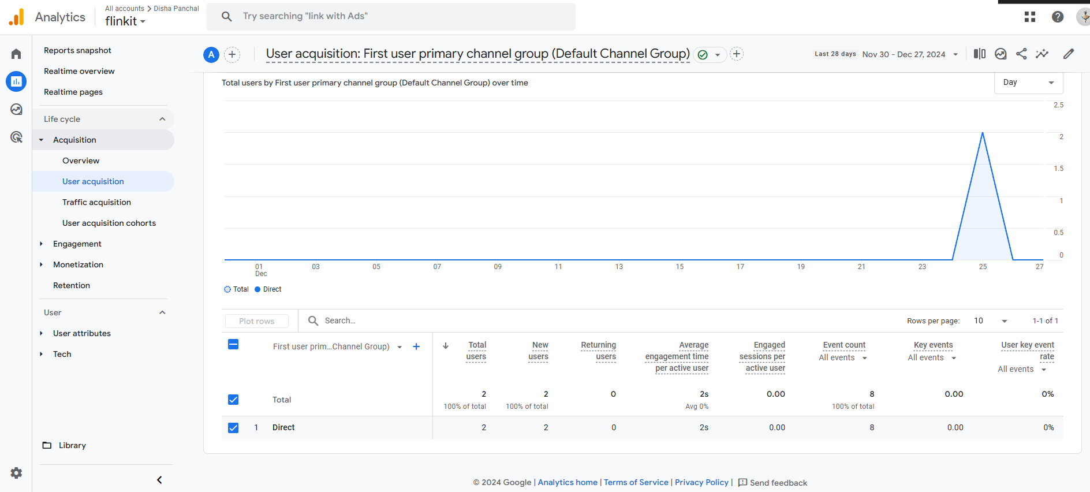

**Difference between GA4 & universal analytics.**

|  |  |  |  |
| --- | --- | --- | --- |
| SR.NO |  | GA4 | UNIVERSAL ANALYTICS |
| 1 | Data Collection Model | * Uses an event-based data model where every interaction (pageview, click, purchase, etc.) is treated as an event. * Provides more flexibility for tracking cross-platform interactions (web, app, and other digital platforms). | * Based on a session-based tracking model. * Relies on pageviews, events, and hits as primary metrics. * Focuses heavily on desktop-oriented web analytics. |
| 2 | Cross-Platform Tracking | * Designed for cross-platform tracking, unifying data from apps and websites in one property. * Enables better analysis of customer journeys across devices. | * Limited ability to track user interactions across multiple platforms. * Primarily designed for websites. |
| 3 | Reporting Interface | * Offers customizable reports and focuses on exploratory data analysis (e.g., funnel analysis, pathing). * Simplified reporting dashboard but requires more configuration for detailed insights. | * Provides predefined reports with detailed data tables. * Customization is limited compared to GA4. |
| 4 | Privacy and Compliance | * Built with privacy-first principles, including better data anonymization and flexibility in handling user data. * Doesn’t log IP addresses by default. | * Offers limited controls for user data privacy. * Requires more manual adjustments to meet modern privacy regulations like GDPR. |
|  |  |  |  |

• **Link Clicks**: The number of times users click on a hyperlink on a webpage, email, or ad. This metric helps measure engagement and navigation patterns.

• **Page Load**: The time it takes for a webpage to fully load and become usable for a visitor. It’s a crucial performance metric for user experience and SEO.

• **Time (How long a visitor stayed on a particular page)**: Also known as "time on page," this metric tracks the duration a visitor spends on a specific webpage, indicating engagement level.

• **Button Click**: The number of times a visitor clicks on a specific button (e.g., "Buy Now," "Submit," or "Sign Up"), reflecting conversions or desired actions.

**Create a goal for your business and study reports whether it has been completed or not**

**Connect your blog to Google Analytics and study the different types of traffic on your site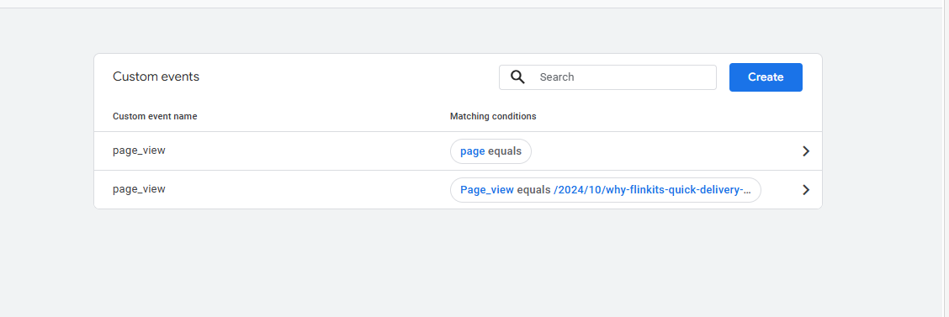  
There are 5 main types of traffic you’ll want to evaluate, including:**

1. Direct traffic. Direct traffic is measured whenever someone types your URL into their web browser or clicks on a bookmark.

2. Organic traffic. Organic traffic is what you’ll measure if you want to evaluate the success of your search engine optimization (SEO) campaign.

3. Referral traffic. You may also want to look at referral traffic, the number of people who click external links to visit your site.4. Social traffic. If you spend a lot of time on social media marketing, you’ll also want to watch your social traffic—the number of people visiting your website from popular social media sites.

5. Paid traffic. Finally, consider paid traffic. You’ll only see this segment if you’re using pay per click (PPC) advertising, but it’s worth considering as a fraction of the whole.